**Experiment: 6**

PART A

(PART A: TO BE REFFERED BY STUDENTS)

**Aim:** **To study concept of arrays in C++ programming**

**Learning Outcomes: Learner would be able to**

1. Interpret the scenario to decide on selective and repetitive blocks.
2. Explain using algorithm and flowchart working of 1-D array as per scenario.

**Task 1:** Write a C++ program to find the minimum and maximum value from an array

**Task 2:** Write a program to print binary equivalent of a decimal number using array.

**Task 3:** Write a C++ program to copy one array into another array. The copying must be in such a way that second array consists even elements followed by odd elements.

**Theory:**

It is group of logically related data, stored in contiguous blocks of memory under common name. An Array is homogeneous or similar type of data items under common name. Data items or elements of arrays are separated from each other by subscript or index.

C++ Supports following arrays.

1. One Dimensional Arrays - One dimensional arrays are represented as set of values in one row.

2. Two or Multi-Dimensional Arrays - Multi-dimensional arrays are views as table containing data in row & column.

**Declaring One Dimensional Array:** We must declare array before use, and following is the syntax:

**Syntax**:- data_type arr_name[size];

In above syntax,

* data_type-can be‟char‟,‟int‟,‟float‟or‟double‟.
* arr_name-is similar to normal variables name.
* size- is is the maximum size of array & size should be integer constant.

**Example** : int marks[50];

In primary memory array will get contiguous block of memory as shown in following declaration of integer array “a” of size 5.

**int a[5] ;**

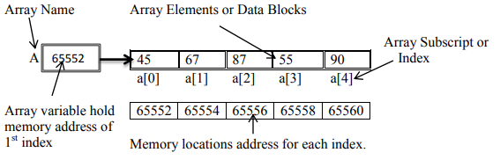

PART B

(PART B: TO BE COMPLETED BY STUDENTS)

Students must submit the soft copy as per following segments within two hours of the practical. The soft copy must be uploaded on the portal at the end of the practical. The filename should be **PPS_batch_rollno_experimentno Example: PPS_B2_B001_Exp1**

|  |  |
| --- | --- |
| **Roll No.:** | **Name:** |
| **Prog/Yr/Sem:** | **Batch:** |
| **Date of Experiment:** | **Date of Submission:** |

**Task 1:**

**Task 2:**

**Task 3:**

**Conclusion (Learning Outcomes):** Reflect on the questions answered by you jot down your learnings about the Topic: One dimensional array.

**Home Work Questions:**

1. Can array index be negative?
2. Write a program to find similar elements in an array and compute the number of times they occur.